Harrisburg Diocesan Council of Catholic Women
99th Annual Convention – April 26, 2025
Diocesan Center, Harrisburg, PA

OVERNIGHT LODGING INFORMATION

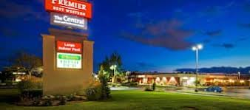
Best Western Premier The Central Hotel & Conference Center
800 E Park Dr, Harrisburg, PA 17111•(717) 561-2800

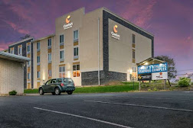
Comfort Inn & Suites Harrisburg - Hershey West
1001 Briarsdale Rd, Harrisburg, PA 17109 • (717) 558-8535
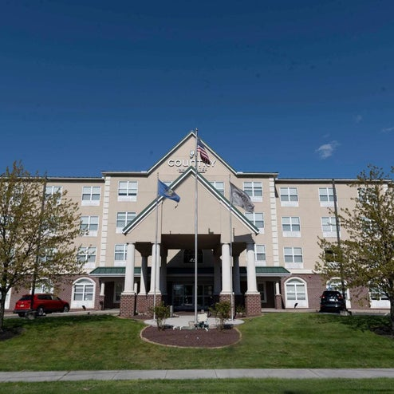
Country Inn & Suites by Radisson, Harrisburg - Hershey West, PA
1025 Peiffers Lane, Harrisburg, PA, 17109 • (833) 577-4832
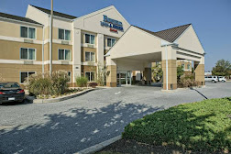
Fairfield Inn & Suites Harrisburg Hershey
1018 Briarsdale Rd, Harrisburg, PA 17109 • (717) 412-4326

